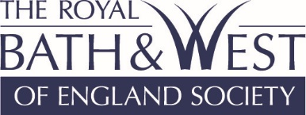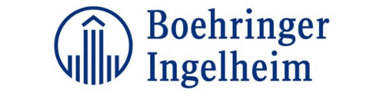

The Farm Vet of the Future Competition – The Peter Clark Award sponsored by Boehringer Ingelheim Animal Health
We are delighted to announce the launch of the Farm Vet of the Future Competition 2023. This competition is open to UK final year vet students intending on becoming farm vets. Entries will comprise of a piece of existing work that demonstrates your clinical knowledge and interest (case report, herd health project, elective, dissertation) and also 300-500 words on your view on the role of the farm vet of the future. Entries are to be received by Tuesday 11th April. Shortlisted entrants will then be asked to attend an online meeting to discuss their entry.
The winner and runner-up will be invited to attend the Royal Bath and West Show on Thursday 1st June when the winner will be announced. It is important that the winner and runner up can commit to attending the Show. Email your piece of existing work and complete the section below and please return to rachel.freestone@bathandwest.co.uk by the closing date.
Can you also please nominate a referee who might support your entry. They will only be approached in a tiebreak situation. Information required - Name, email address & phone number. By entering the competition you are allowing us to contact your referee.

Please provide 300-500 words on your view of role of the farm vet of the future

